**Using the WHO Growth Chart**

Growth is not only a result of nutrition but also a result of inherited factors. Ethnicity can influence a child’s growth patterns, and so some countries have their own growth charts. However, the [World Health Organization’s (WHO) growth charts](http://www.who.int/childgrowth/standards/en/) are used most often and considered the standard around the world. Learn more about:

» [How to Take Measurements](http://www.orphannutrition.org/nutrition-best-practices/growth-charts/using-the-who-growth-charts/#how_to_take_measurements)

» [How to Apply Measurements to Growth Charts](http://www.orphannutrition.org/nutrition-best-practices/growth-charts/using-the-who-growth-charts/#how_to_apply_measurements_to_growth_charts)

**How to Take Measurements**

Typical measurements taken for children 0-24 months include:

* [Head circumference](http://www.orphannutrition.org/nutrition-best-practices/growth-charts/using-the-who-growth-charts/#head_circumference)
* [Length](http://www.orphannutrition.org/nutrition-best-practices/growth-charts/using-the-who-growth-charts/#length)
* [Weight](http://www.orphannutrition.org/nutrition-best-practices/growth-charts/using-the-who-growth-charts/#weight)

Measurements should be taken at regular intervals in order to observe reliable trends. Recommendations for measurement intervals include:

* Infants (0-12 months): every 2 months
* Young Children: at 15, 18, 24 and 30 months
* Ages 3+: every year

[Click here for a specific measurement schedule](http://www.orphannutrition.org/TrainingMaterials/GrowthCharts/Growth%20Charts%20Module_Branded%20Measurement%20Schedule%20handout.pdf).

**Head Circumference**

Head circumference is a measurement taken around the largest part of a child’s head. This measurement is typically taken with children ages 0-3 years old.

The measurement should be taken with a measuring tape that cannot be stretched. This is typically a flexible, metal measuring tape. To measure, securely wrap the tape around the widest possible circumference of the head. Typically, this is from 1-2 finger-widths above the eyebrow on the forehead to the most prominent part of the back of the head. Take the measurement three times and select the largest measurement to the nearest 0.1cm.

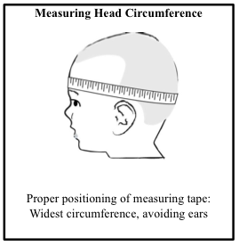

During the early years of a child’s life, head circumference is an important measurement because it indirectly reflects brain size and growth. Because almost all brain growth occurs before the age of two, plotting head growth can be used as a general indicator of a young child’s brain health.

[Learn about the head circumference-for-age growth chart](http://www.orphannutrition.org/nutrition-best-practices/growth-charts/using-the-who-growth-charts/#head_circumference_for_age).

» [Back to Top](http://www.orphannutrition.org/nutrition-best-practices/growth-charts/using-the-who-growth-charts/#top)

**Length**

Length is the linear measurement for infants up to 24 months. Length measurements (instead of height) are also taken for children 24 to 36 months who cannot stand without assistance.

Length is measured when children are in a recumbent (lying down) position. The most accurate way to measure length is by using a calibrated length board. Length boards should have a fixed headpiece and a moveable foot piece perpendicular to the surface of the board.

To measure, lay the child on the board with their head against the fixed headpiece. Make sure the child is not wearing shoes or a hairpiece. An assistant may be helpful to hold the child still and centered on the board. Straighten the child’s legs and adjust the moveable foot piece so the soles of the feet are against the foot piece. Record the length to the nearest 0.1 cm.

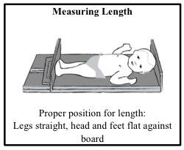

Length is an important determinant of a child’s nutritional status. Children may exhibit slow growth in length if they have been undernourished for a long time.

[Learn about the length-for-age growth chart](http://www.orphannutrition.org/nutrition-best-practices/growth-charts/using-the-who-growth-charts/#length_for_age).

» [Back to Top](http://www.orphannutrition.org/nutrition-best-practices/growth-charts/using-the-who-growth-charts/#top)

**Weight**

Weight is a measurement taken throughout the lifespan to help determine trends and current nutritional status.

Infant weight can be accurately measured using one of several different pieces of equipment. If available, a pan-type pediatric scale allows a child to be weighed while lying down. These pediatric scales are either electronic or beam scales with non-detachable weights, and are accurate to the nearest 10 gram. Another option is a hanging scale. A hanging scale needs to be attached to a sturdy structure (e.g. building rafter, door frame) and the child is suspended from the scale in weighing pants.

To measure, make sure the child is wearing as little clothing as possible and that no one is touching the child. Read the scale at eye-level and record weight to the nearest 10 gram. Repeat the measurement three times, exclude values that appear skewed, and find the average.

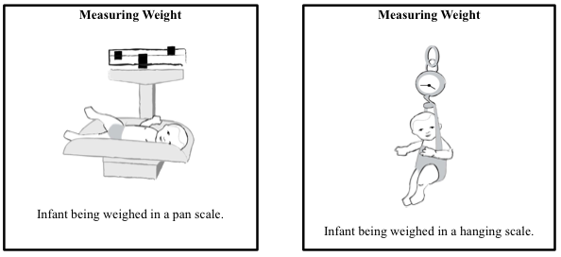

In the event a baby scale is unavailable, an adult standing scale can be used to measure infant weight. Weigh an adult first, and then weigh the same adult while holding a child. Find the difference between the two weights – this is the infant’s weight.

Weight-for-age is an important indicator of a child’s nutritional status over time, such as trends in underweight. [Learn about the weight-for-age growth chart](http://www.orphannutrition.org/nutrition-best-practices/growth-charts/using-the-who-growth-charts/#weight_for_age) .

Weight-for-length, on the other hand, helps determine a child’s current nutritional status. This is the key indicator for determining wasting in children. [Learn about the weight-for-length growth chart](http://www.orphannutrition.org/nutrition-best-practices/growth-charts/using-the-who-growth-charts/#weight_for_length).

» [Back to Top](http://www.orphannutrition.org/nutrition-best-practices/growth-charts/using-the-who-growth-charts/#top)

**How to Apply Measurements to Growth Charts**

These measurements can then be applied to the most commonly used growth charts.

* [Head circumference-for-age](http://www.orphannutrition.org/nutrition-best-practices/growth-charts/using-the-who-growth-charts/#head_circumference_for_age)
* [Length-for-age](http://www.orphannutrition.org/nutrition-best-practices/growth-charts/using-the-who-growth-charts/#length_for_age)
* [Weight-for-age](http://www.orphannutrition.org/nutrition-best-practices/growth-charts/using-the-who-growth-charts/#weight_for_age)
* [Weight-for-length/weight-for-height](http://www.orphannutrition.org/nutrition-best-practices/growth-charts/using-the-who-growth-charts/#weight_for_length)

On the WHO Growth Charts, there are five curves. The middle curve (labeled 0) is the median, or average. This line is also called the 50th percentile, because 50 percent of all children are above the median and 50 percent fall below. Generally, most healthy children fall near the median curve, either a little above or below. A normally growing child will typically have a growth curve that is somewhat parallel to the median.

Other lines on the curve, called z-score lines, indicate distance from the median curve. Points far from the median, such as a 3 or -3, typically indicate some kind of growth problem. One point on its own does not give an accurate assessment of a child’s growth. Instead, a series of points provides insight into a child’s growth patterns and tendencies over time.

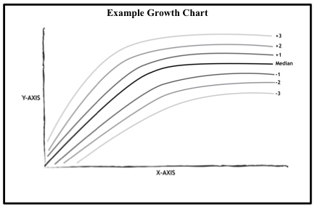

» [Back to Top](http://www.orphannutrition.org/nutrition-best-practices/growth-charts/using-the-who-growth-charts/#top)

**Head Circumference-for-Age**

On the head circumference-for-age growth chart, the child’s age in months is along the bottom (x-axis) and the child’s head circumference (in centimeters) is up the left side (y-axis).

To plot a point, find the mark representing the child’s age on the bottom of the chart. Follow the line upward to the horizontal line corresponding to the child’s head circumference. At this intersection, draw a visible mark using a pen or pencil.

A pattern of individual points that is more or less parallel to the median on the head circumference growth chart indicates normal brain development.

Children with head circumference falling below the -2 z-score line are considered to have microcephaly. In contrast, macrocephaly is a condition when head circumference is higher than the 2 z-score line. It is important that a medical doctor assess children found to have either microcephaly or macrocephaly. There may be serious medical implications since it is assumed head circumference serves as a rough proxy for brain growth.

[WHO Boys 0-2 head circumference-for-age growth chart](http://www.who.int/childgrowth/standards/second_set/cht_hcfa_boys_z_0_2.pdf)

[WHO Girls 0-2 head circumference-for-age growth chart](http://www.who.int/childgrowth/standards/second_set/cht_hcfa_girls_z_0_2.pdf)

» [Back to Top](http://www.orphannutrition.org/nutrition-best-practices/growth-charts/using-the-who-growth-charts/#top)

**Length-for-Age**

On the length-for-age chart, the child’s age in months is along the bottom (x-axis) and the child’s length (in centimeters) is up the left side (y-axis).

To plot a point, find the mark representing the child’s age on the bottom of the chart. Follow the line upward to the horizontal line corresponding to the child’s length. At this intersection, draw a visible mark using a pen or pencil.

In some countries, children tend to be of shorter stature and will regularly fall below the median on the length-for-age growth chart. When using the WHO growth charts it is important to keep in mind that if a child’s growth pattern is parallel to the median line, they are growing along a normal curve despite their low length/height.

Children are considered to be [stunted](http://www.orphannutrition.org/understanding-malnutrition/macronutrient-malnutrition/#stunting) when their length-for-age falls below the -2 z-score line. Infants and small children with stunting may regain some lost growth potential if nutrition intervention occurs before the age of 2. However, among children over 2 in nutritionally deprived situations, stunting is virtually irreversible.

[WHO Boys 0-2 length-for-age growth chart](http://www.who.int/childgrowth/standards/cht_lfa_boys_z_0_2.pdf)

[WHO Girls 0-2 length-for-age growth chart](http://www.who.int/childgrowth/standards/cht_lfa_girls_z_0_2.pdf)

» [Back to Top](http://www.orphannutrition.org/nutrition-best-practices/growth-charts/using-the-who-growth-charts/#top)

**Weight-for-Age**

On the weight-for-age growth chart, the child’s age in months is along the bottom (x-axis) and the child’s weight (in kilograms) is up the left side (y-axis).

To plot a point, find the mark representing the child’s age on the bottom of the chart. Follow the line upward to the horizontal line corresponding to the child’s weight. At this intersection, draw a visible mark with a pen or pencil.

Children are considered underweight if their weight-for-age falls below the -2 z-score line. A point at -3 z-score line indicates severe underweight and undernourishment, meaning the child is in need of special care. Severe underweight may be a result of [stunting](http://www.orphannutrition.org/understanding-malnutrition/macronutrient-malnutrition/#stunting), [wasting](http://www.orphannutrition.org/understanding-malnutrition/macronutrient-malnutrition/#wasting) or both.

[WHO Boys 0-2 weight-for-age growth chart](http://www.who.int/childgrowth/standards/cht_wfa_boys_z_0_2.pdf)

[WHO Girls 0-2 weight-for-age growth chart](http://www.who.int/childgrowth/standards/cht_wfa_girls_z_0_2.pdf)

» [Back to Top](http://www.orphannutrition.org/nutrition-best-practices/growth-charts/using-the-who-growth-charts/#top)

**Weight-for-Length/Weight-for-Height**

On the weight-for-length growth chart, the child’s length (in centimeters) is along the bottom (x-axis) and the child’s weight (in kilograms) is up the left side (y-axis).

Weight-for-length is used typically for children 0-24 months, whereas weight-for-height is used for older children who are able to stand up on their own. It can be very difficult to accurately assess weight-for-length for infants less than 55 cm long.

To plot a point, find the mark representing the child’s length on the bottom of the chart. Follow the line upward to the horizontal line corresponding to the child’s weight. At this intersection, draw a visible mark using a pen or pencil.

Children with weight-for-length falling below the -2 z-score line are considered to be [wasted](http://www.orphannutrition.org/understanding-malnutrition/macronutrient-malnutrition/#wasting). Wasting is a major cause of mortality in children under 5, so children assessed as being “wasted” need immediate medical attention. Children with weight-for-length above the +2 z-score line are considered overweight and may be at risk for child obesity.

[WHO Boys 0-2 weight-for-length growth chart](http://www.who.int/childgrowth/standards/cht_wfl_boys_z_0_2.pdf)

[WHO Girls 0-2 weight-for-length growth chart](http://www.who.int/childgrowth/standards/cht_wfl_girls_z_0_2.pdf)